**AIT-524, Class 08, Practice Problems**

**Tanmoy Chowdhury, G01025893**

**Questions:**

1. Use the SELECT statement to retrieve all columns from one of the tables in the database.

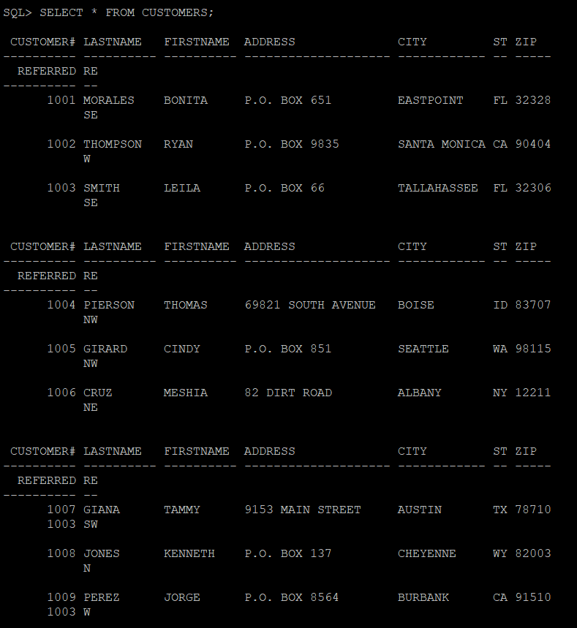

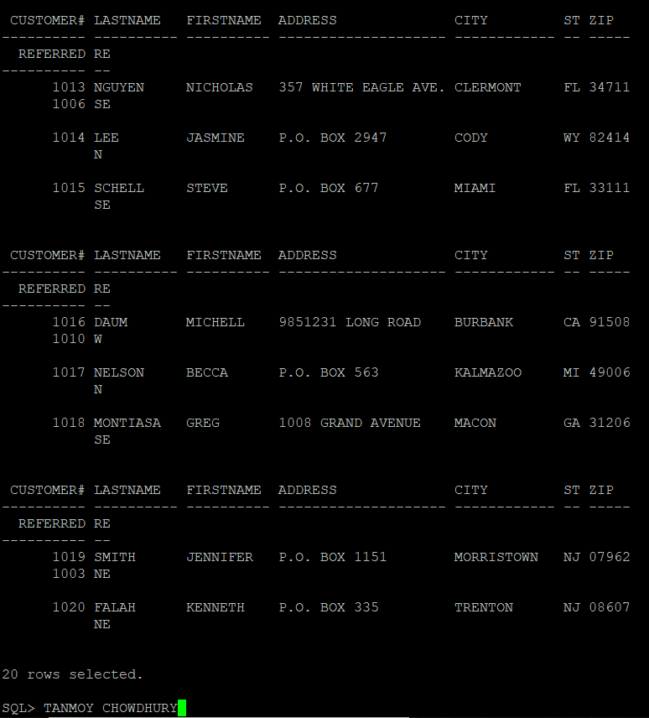

1. Use the SELECT statement to retrieve several columns from one of the tables in the database.

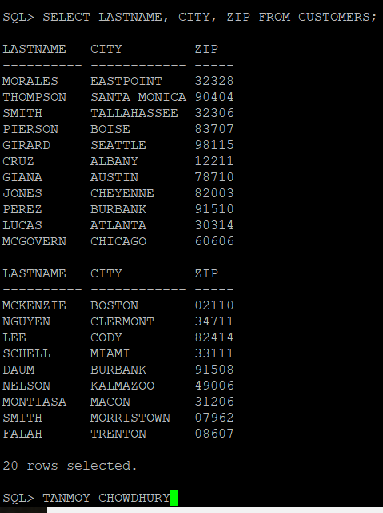

1. Use the SELECT statement to retrieve one column from one of the tables in the database. Use an alias for that column.

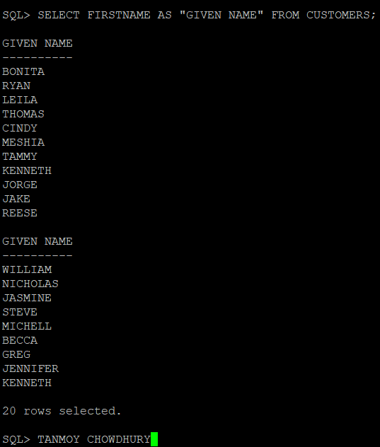

1. Use the SELECT statement to retrieve several columns from one of the tables in the database. For one of the columns, use an alias that contains blank space(s).

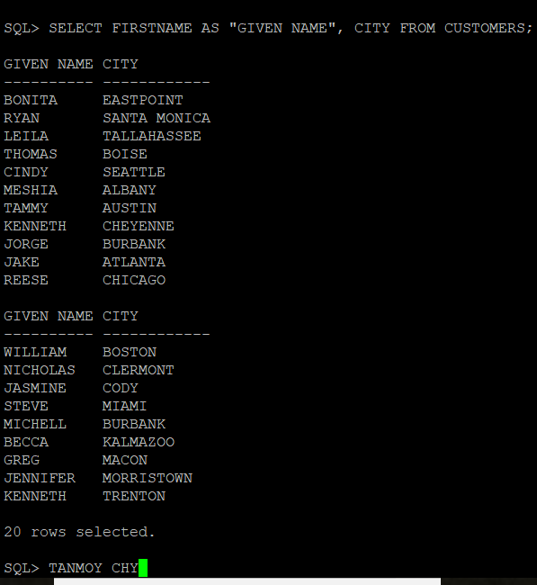

1. Use the SELECT statement to retrieve several columns from one of the tables in the database. Perform a basic arithmetic operation on columns.

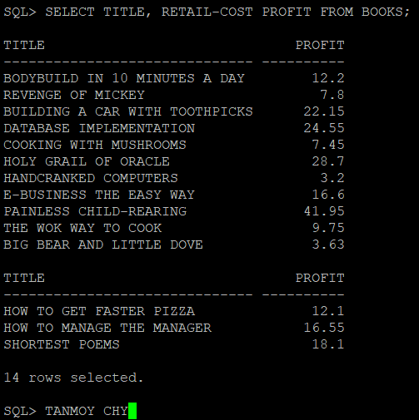

1. Use the SELECT statement to retrieve one column from one of the tables in the database. Use DISTINCT or UNIQUE to suppress duplicates.

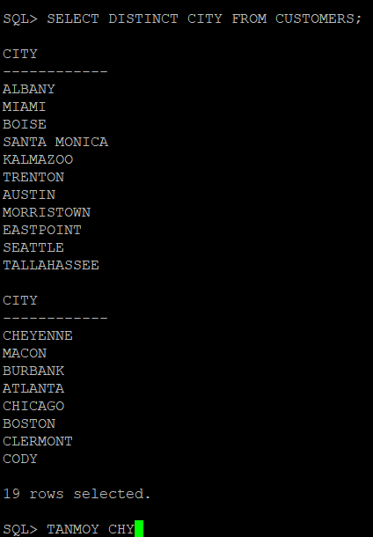

1. Use the SELECT statement to retrieve two character columns from one of the tables in the database. Use concatenation to combine data from the two columns. Make sure to include a space between the two values and use an alias.

